**SAŠA MIRKOVIĆ - TASK 2 RADO CONSULT**

***Info concerning ICOs has been acquired on ICO Drops. Twitter data has been gathered by REST API in R, while the data about 4 coins has been scraped from CoinMarketCap. All of the data and the complete R code can be found on my*** [***GitHub profile***](https://github.com/SasaMirkovic/Crypto)***.***

***Although a lot of the time has been spent on cleaning the data, the process will not be described here, since it is not important for the task at hand.***

I have chosen to compare **ALGO** (122,400,000$ ICO), **LINK** (32,000,000$ ICO) and **XTZ** (228,190,000$ ICO) to **BITCOIN**. Because of the complexity of the task at hand, I have focused on price action, comparing opening and closing prices per day and per month, as well as highest and lowest prices. **Note that there is a difference in the time frame due to the fact that these coins had different starting periods. The scale of the x axis differs because of this.**

Let’s take a look at the results. The following 4 images show us the daily price action for each coin, given through the combination of opening (blue) and closing (red) price per day. As we can see, Bitcoins success could be viewed as an inspiration as well as a driving force for the creation and value of the altcoins presented here.

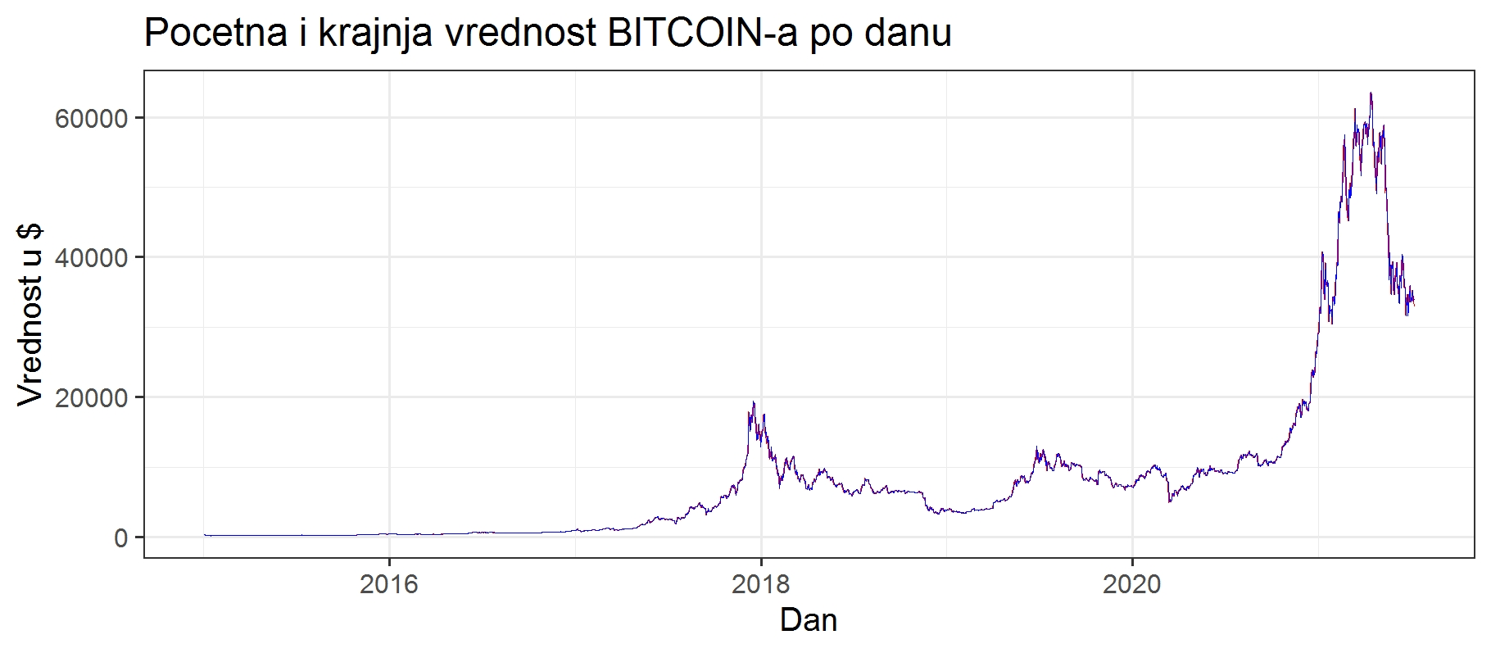**Image 1** - Price change for Bitcoin

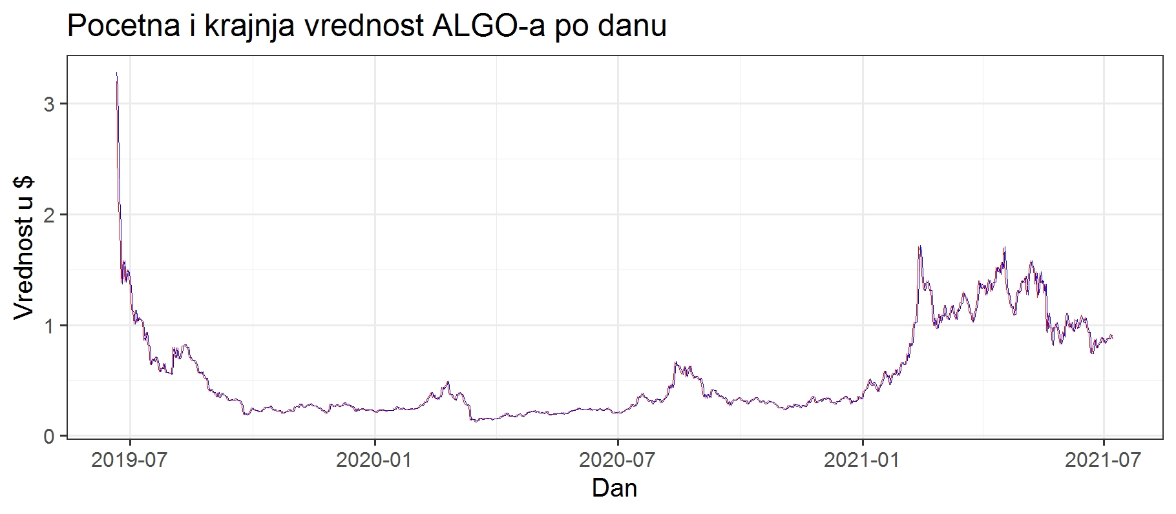**Image 2** - Price change for ALGO

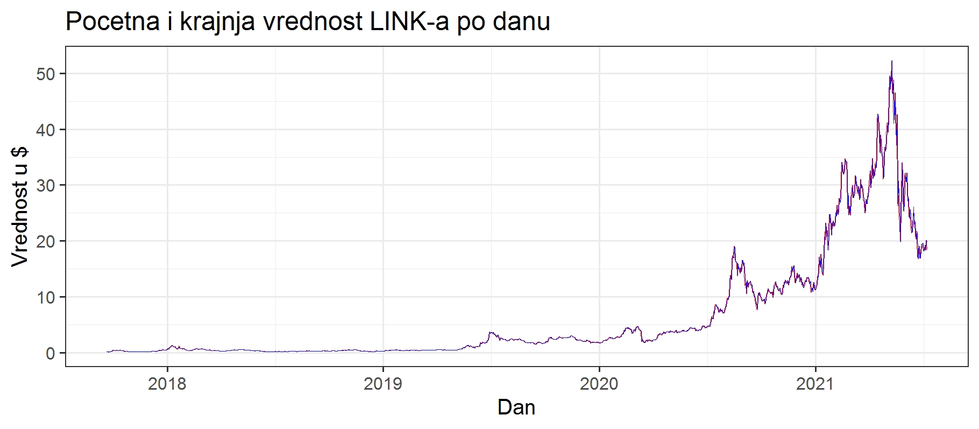**Image 3** - Price change for LINK

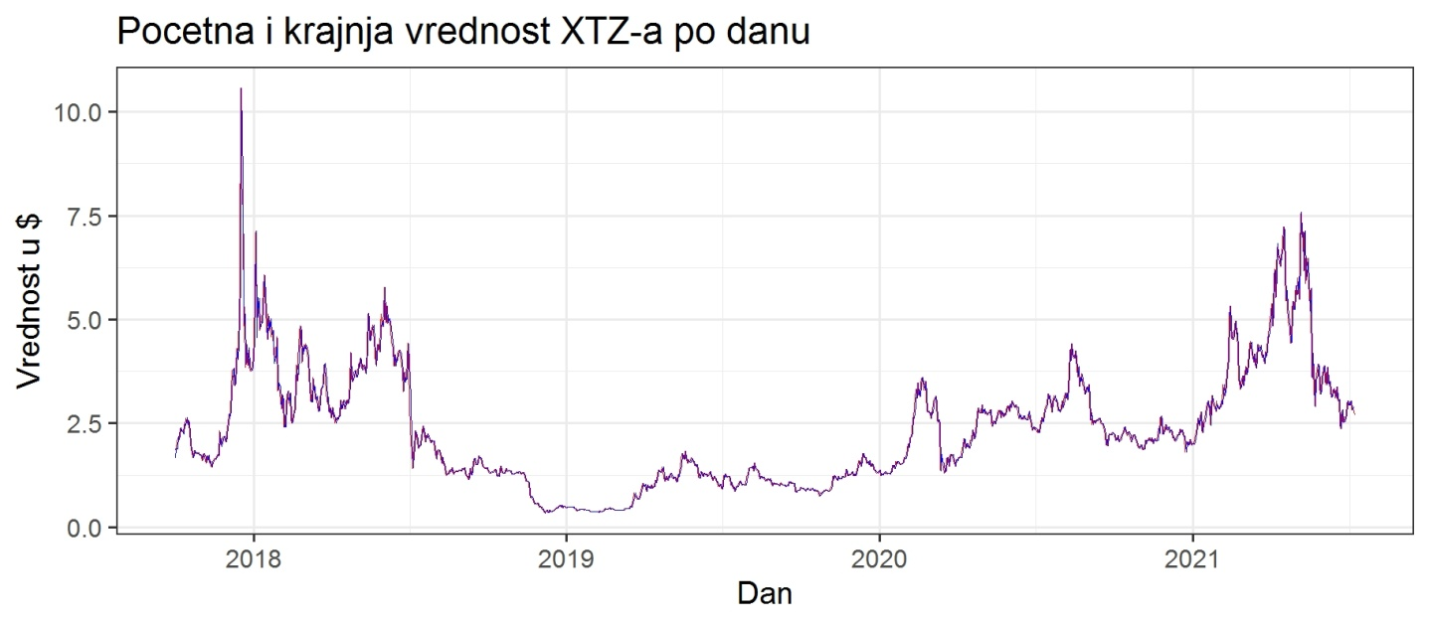**Image 4** - Price change for XTZ

The problem with these charts is that they don’t show us the difference between the opening and closing price per day adequately, so I calculated the difference between them, which can be seen in the following images. We can see that the biggest daily volatility comes with the bullish market and can conclude that the slow and steady acceptance of blockchain technology is probably drawing in inexperienced and profit hungry individuals, eager to jump on the winning team and capitalize on their gains. It is obvious that it is the year 2020. and the COVID-19 pandemic that brought with them the biggest surge in interest for Bitcoin and altcoins.

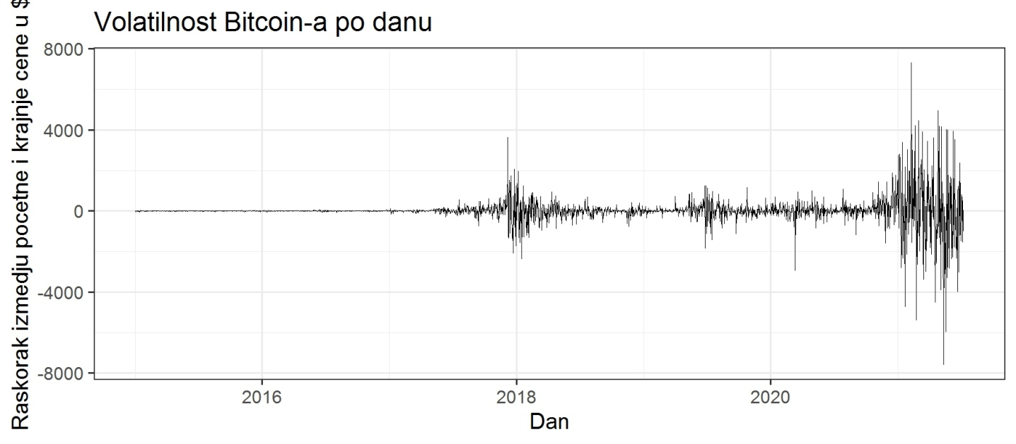**Image 5** - Daily change between opening and closing price for Bitcoin

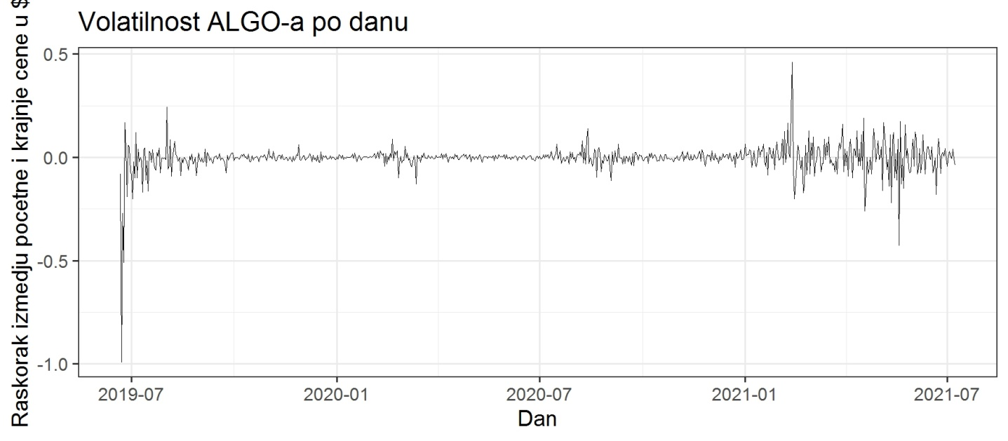**Image 6** - Daily change between opening and closing price for ALGO

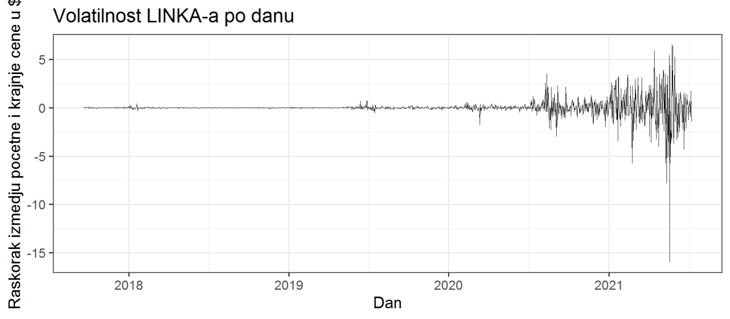**Image 7** - Daily change between opening and closing price for LINK

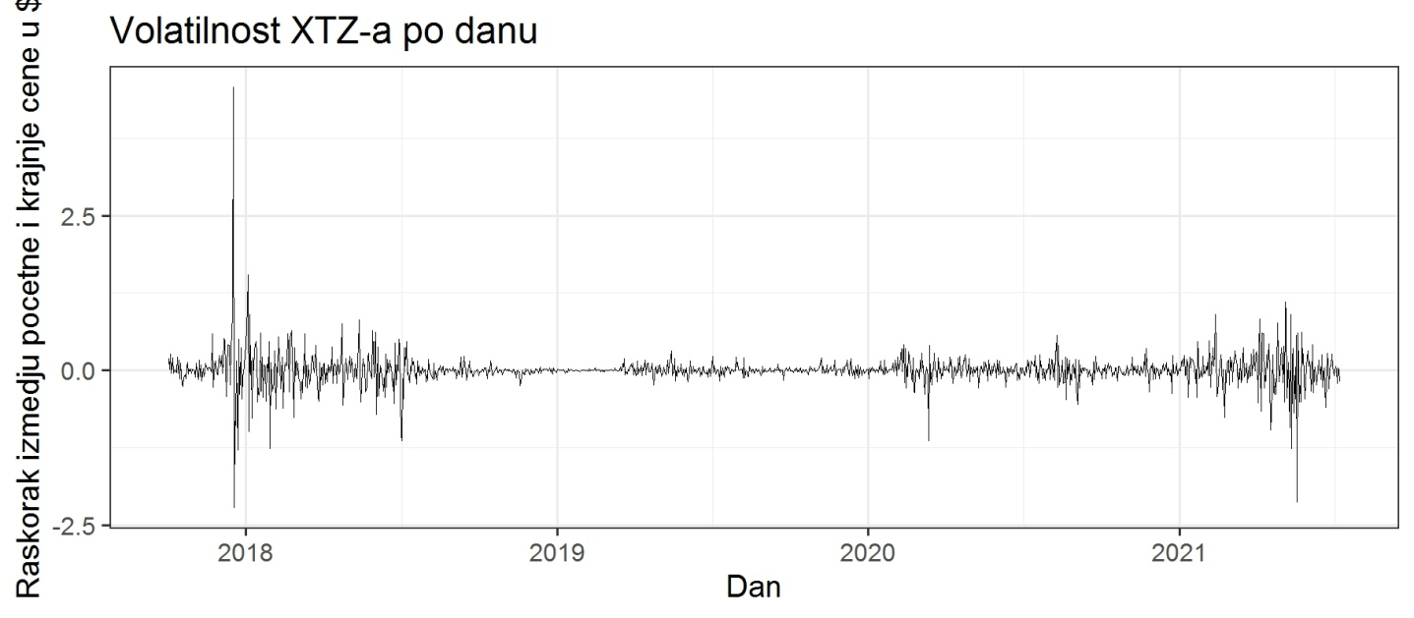**Image 8** - Daily change between opening and closing price for XTZ

What we can see from these pictures is that holding BTC was the best long term strategy (in comparison to the 3 altcoins presented here), but what about short term holds and day trading? The following images give us a view on percentual daily changes in the value of each coin, which should help us better understand their life cycles (because of the great difference in the value of these coins). Judging by these results it would seem that LINK was probably the best day-trading choice, with the most stable positive and negative change of 10% in, what would seem, the most evenly distributed waves, followed by XTZ, whose results are a bit distorted by 4 extreme values (one increase and three falls).

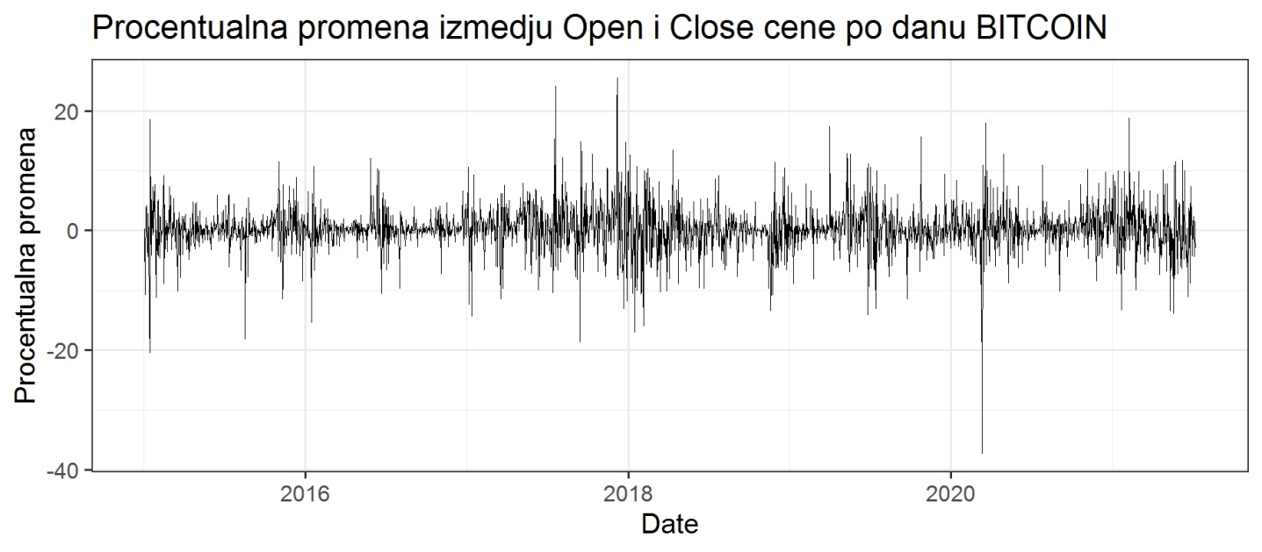**Image 9** - Daily percentage change between opening and closing price for BITCOIN

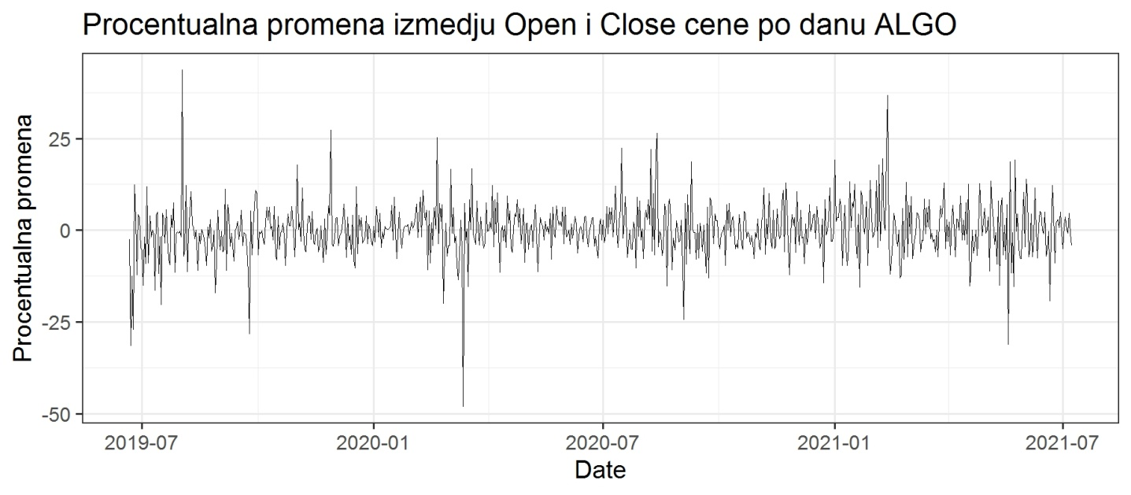**Image 10** - Daily percentage change between opening and closing price for ALGO

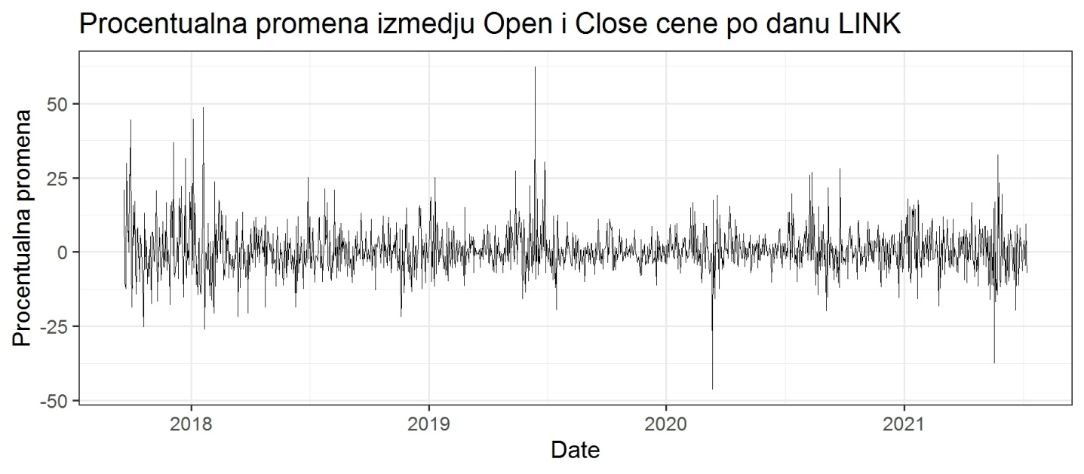**Image 11** - Daily percentage change between opening and closing price for LINK

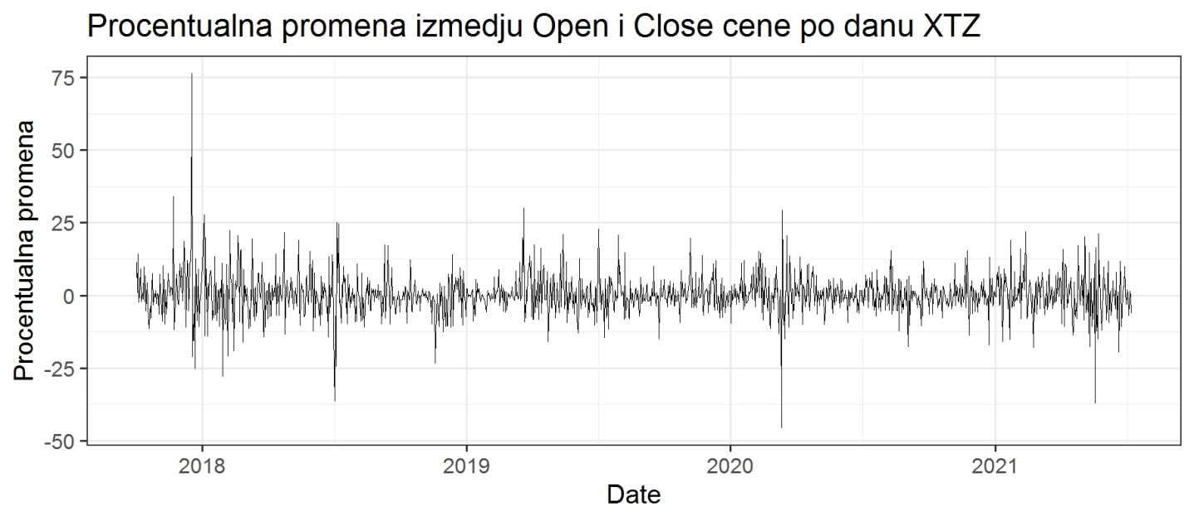**Image 12** - Daily percentage change between opening and closing price for XTZ

If we add some basic statistics to these visualizations, we can get a clearer picture. As we can see from the following images, the assesment given above can be corrected a bit. ALGO's possition doesn't seem radicaly different from the other two coins, although LINK would still be our best bet for short term hold. Mean (red) and median (blue) are given both for positive and negative change.

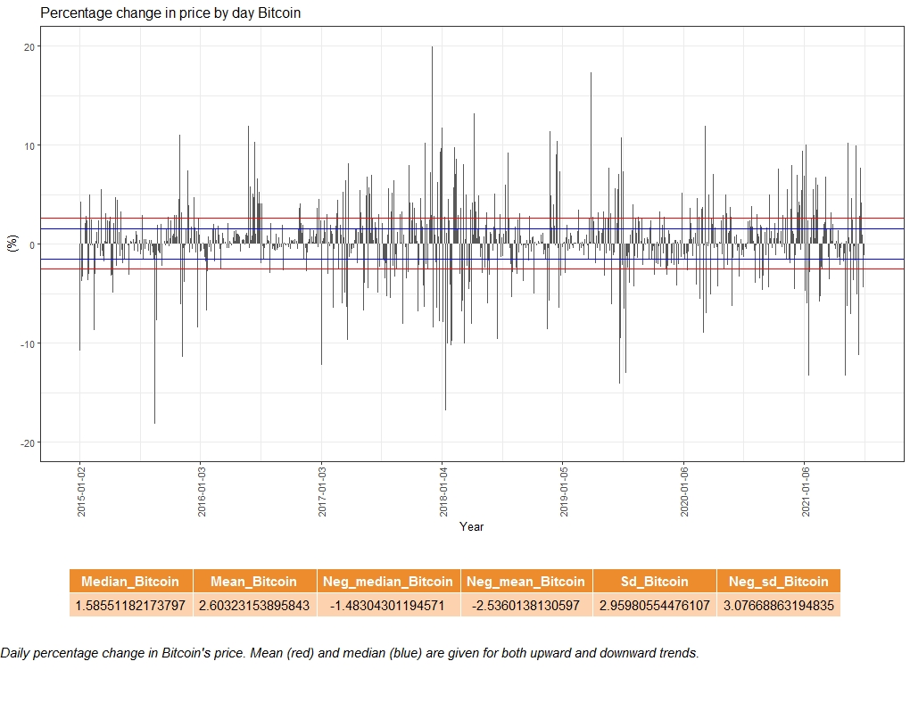

**Image 13** - Percentage change in price by day for Bitcoin with basic statistics

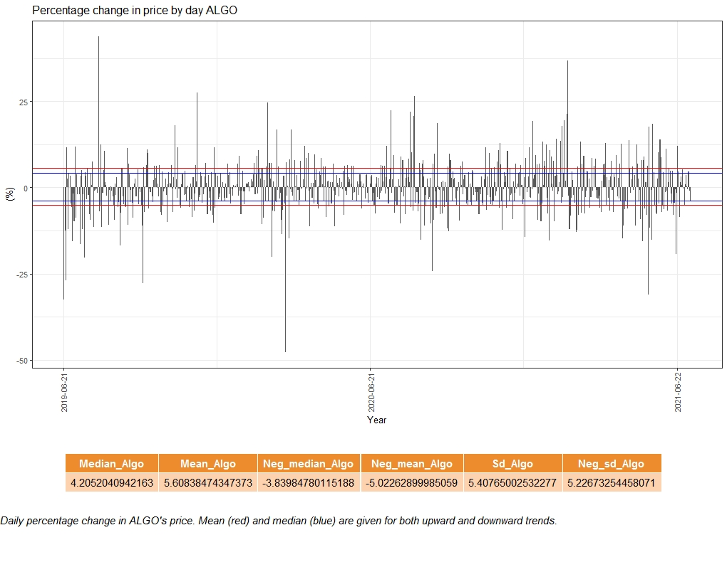

**Image 14** - Percentage change in price by day for ALGO with basic statistics

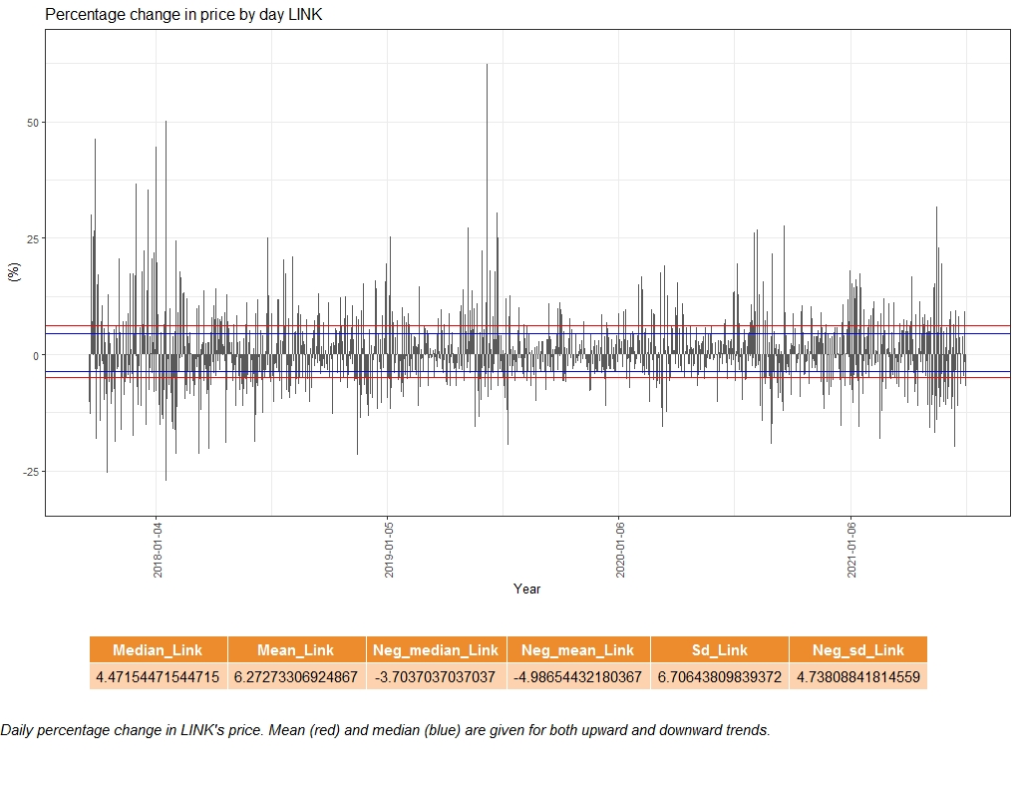

**Image 15** - Percentage change in price by day for LINK with basic statistics

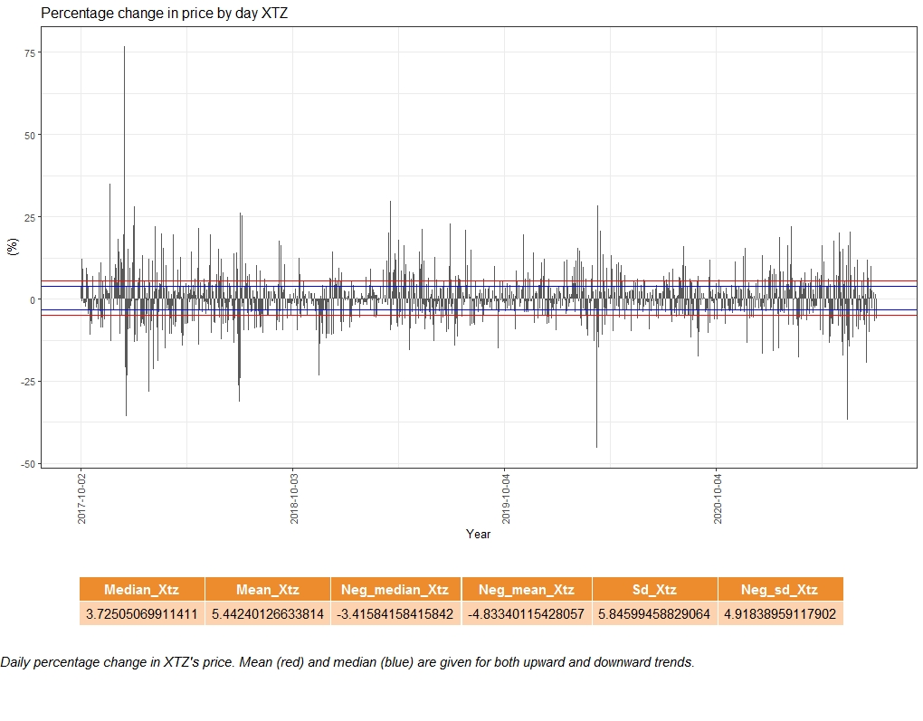

**Image 16** - Percentage change in price by day for XTZ with basic statistics

But what about short term holds? We can get a clear picture by comparing closing daily values for the first (red) and the last (blue) day in one month. Judging by this, it would seem that timely exchange of LINK and XTZ would have made a pretty penny. But in order to be sure, we have to look at the individual differences in percentage change, in order not to get fooled by different proportions. Images 17 - 20 give us this perspective. We can clearly see that although LINK and XTZ had some extreme percentage changes, Bitcoin had the most stable increases (and a solid percentage).

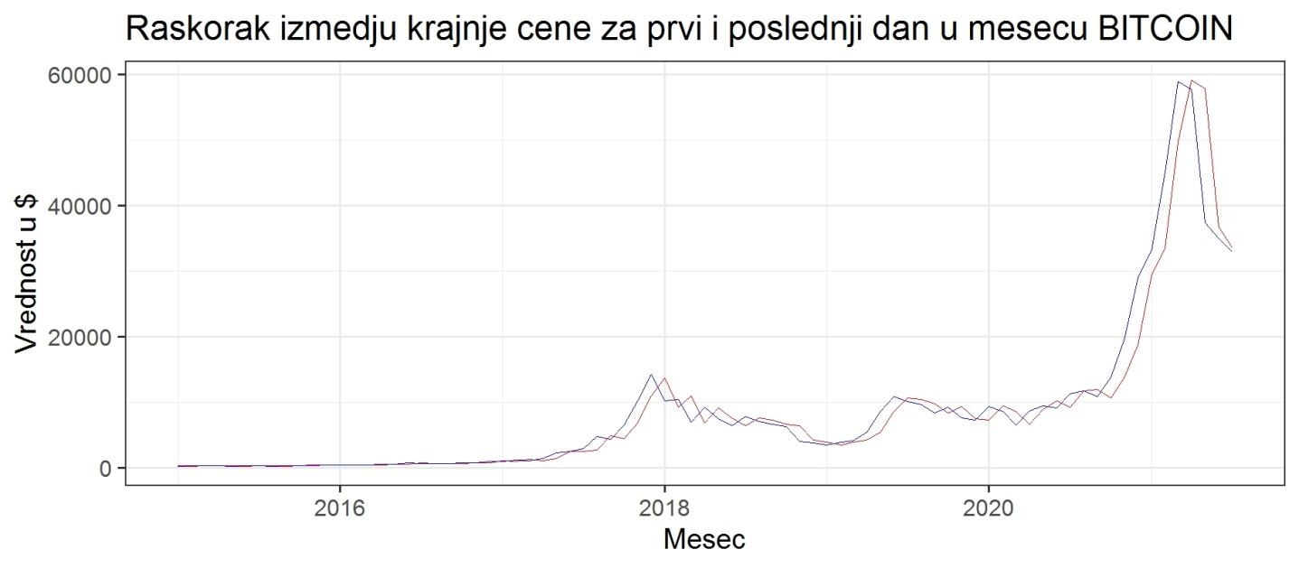**Image 17** - Closing values for the first and last days in one month for BITCOIN

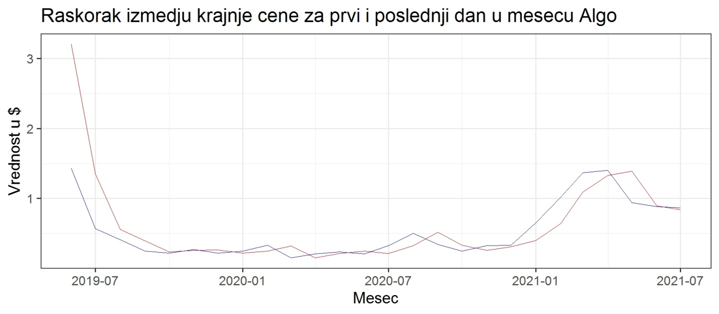**Image 18** - Closing values for the first and last days in one month for ALGO

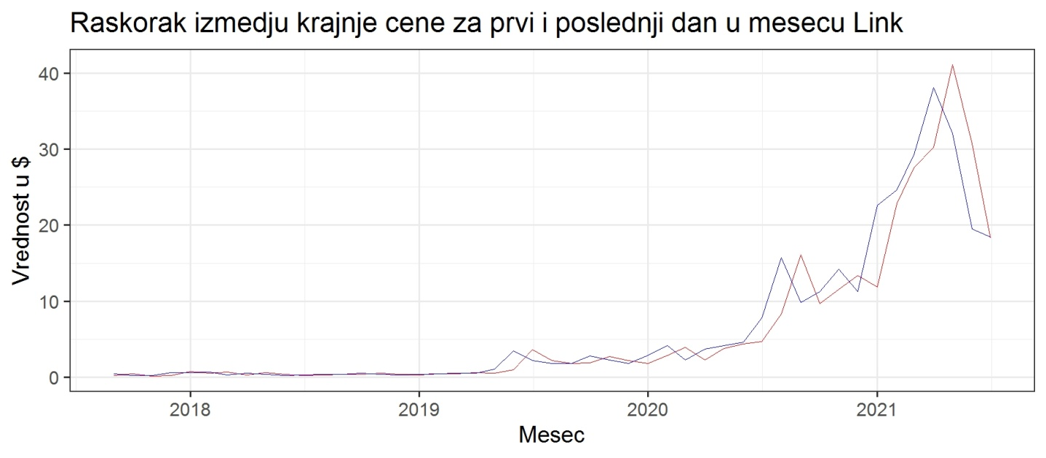**Image 19** - Closing values for the first and last days in one month for LINK

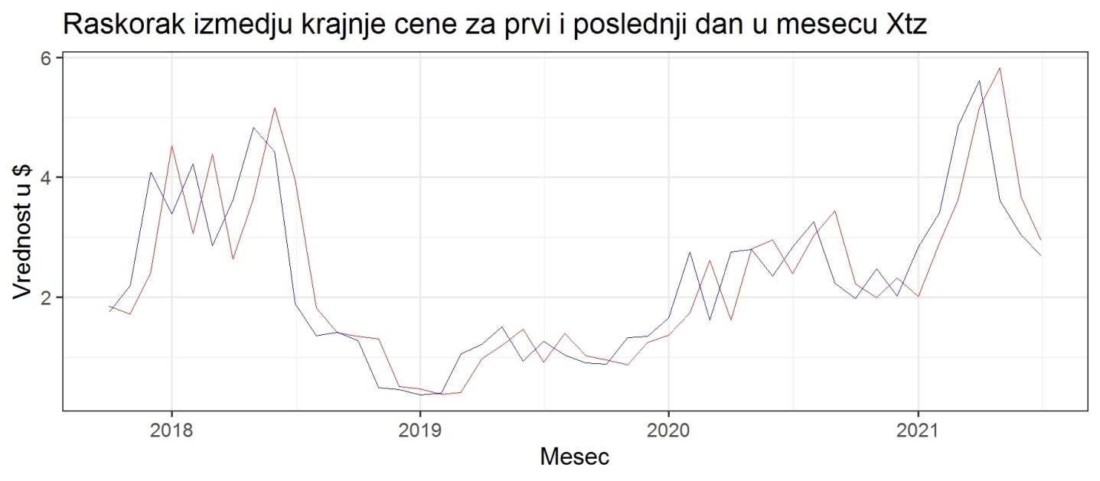**Image 20** - Closing values for the first and last days in one month for XTZ

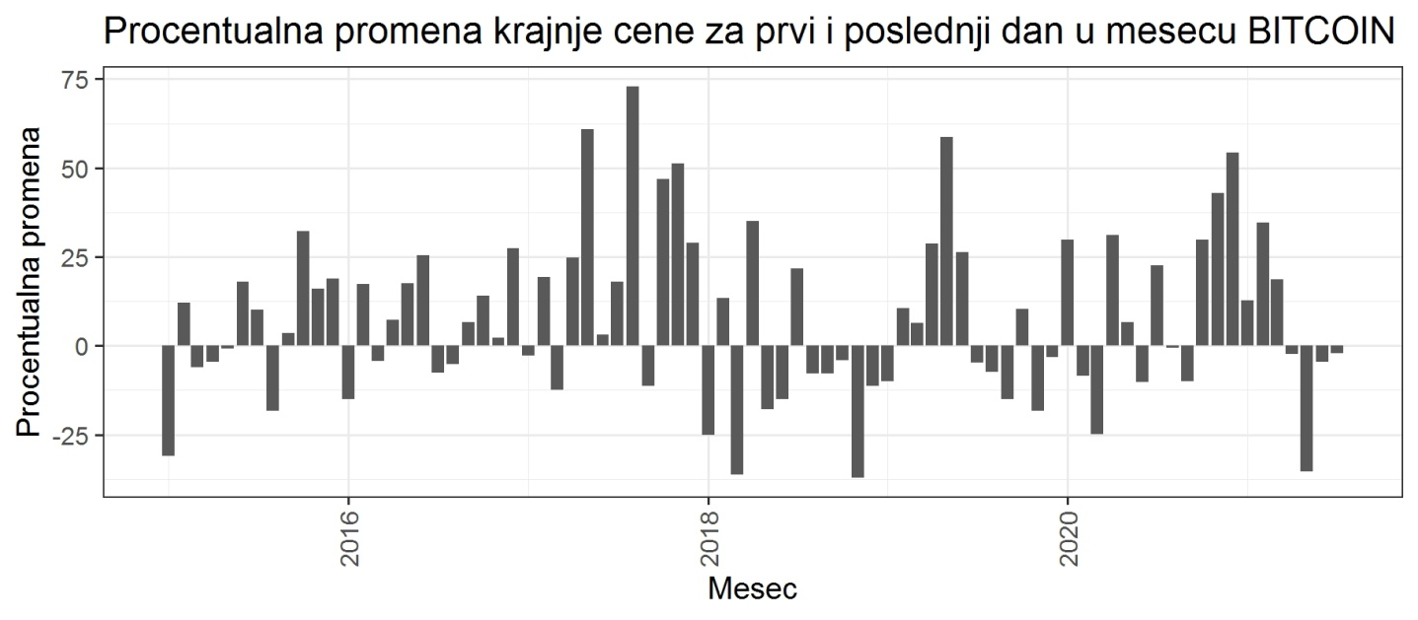**Image 21** - Difference between the closing value on the first and the last day of one month for BITCOIN

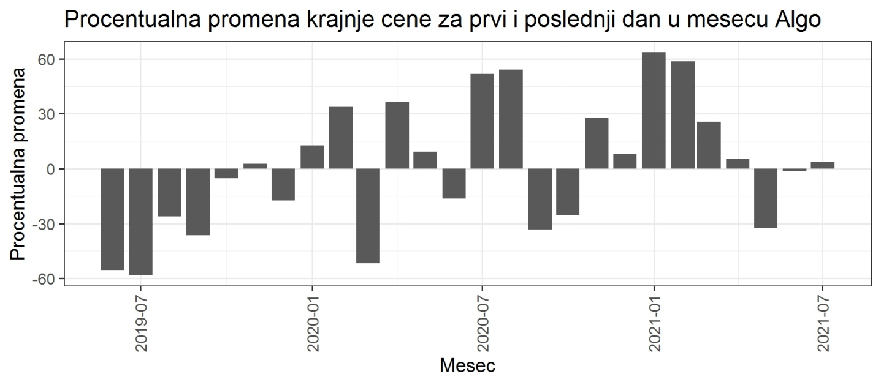**Image 22** - Difference between the closing value on the first and the last day of one month for ALGO

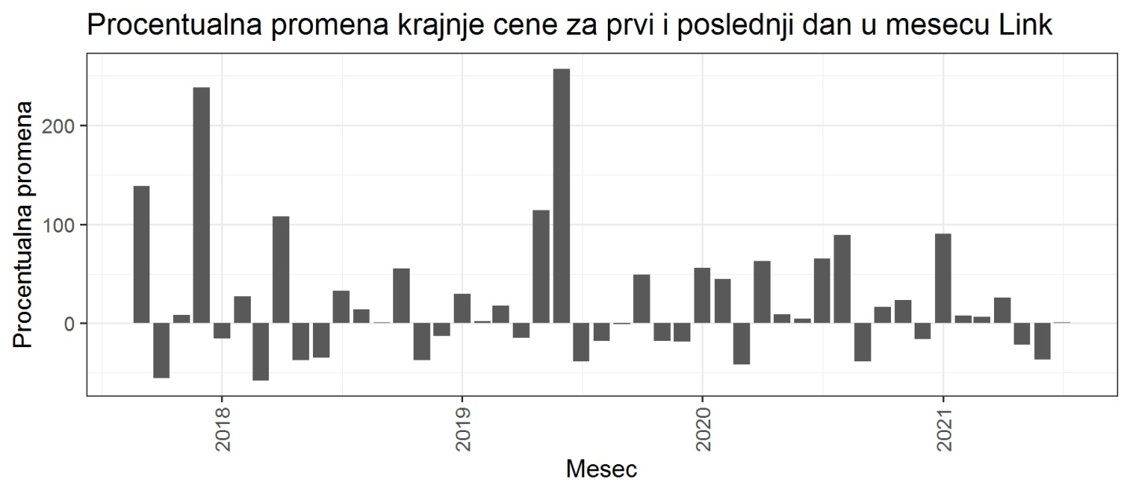**Image 23** - Difference between the closing value on the first and the last day of one month for LINK

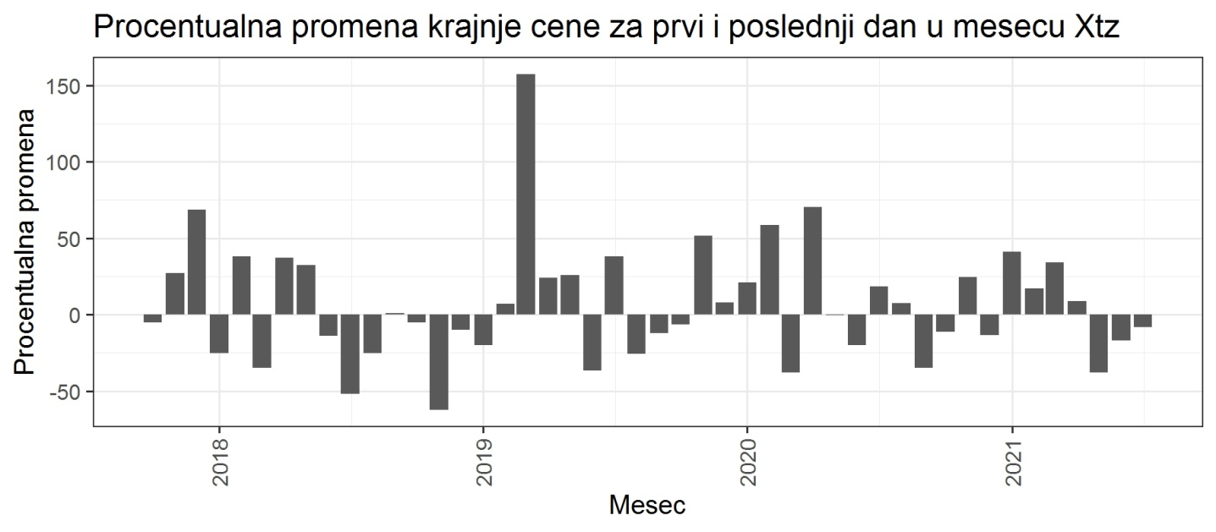**Image 24** - Difference between the closing value on the first and the last day of one month for XTZ

The final thing to check when it comes to the price change is the difference between a daily high (blue) and low (red) price for each coin. The following images give us that information. Again, in order to be sure about our conclusions we have to take the percentage change into account, due to different proportions. It would seem that when it comes to the highest and lowest daily prices, altcoins have experienced bigger changes and could present a better instrument for daily trading for those capable of clever technical analysis. The term “could” should not be taken for granted, because we don’t know whether the lowest daily price preceded the highest or vice versa. Depending on the order of occurrence this could mean high yield or high losses for day traders.

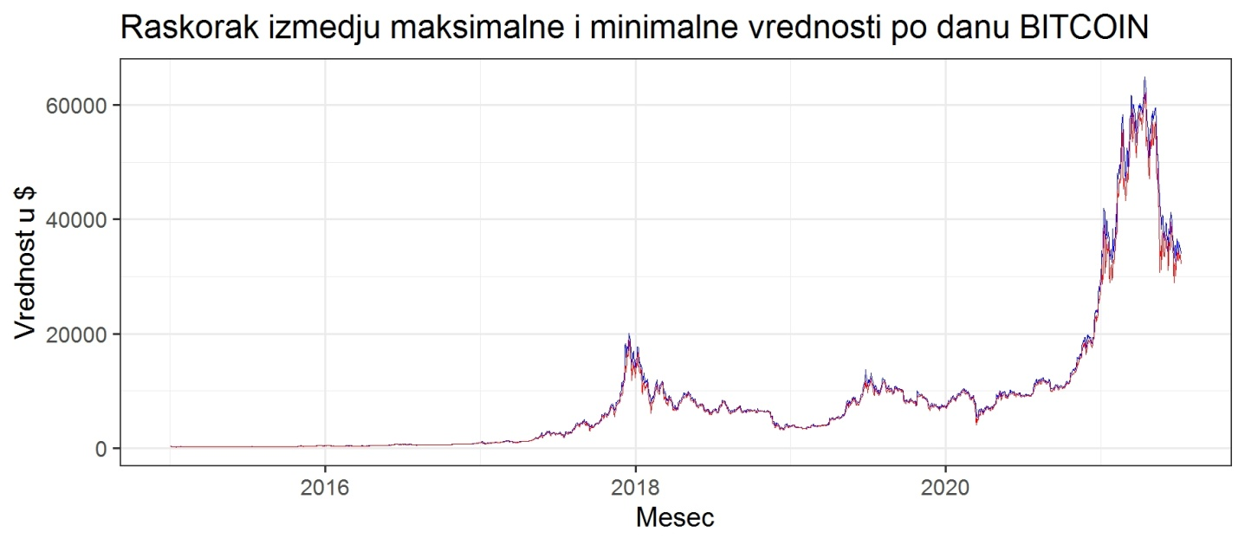**Image 25** - Difference between the minimum and maximum price per day for BITCOIN

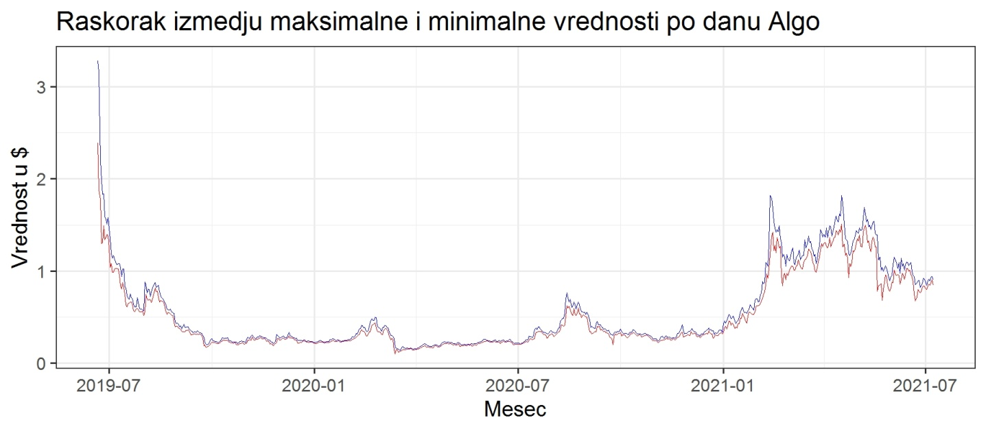**Image 26** - Difference between the minimum and maximum price per day for ALGO

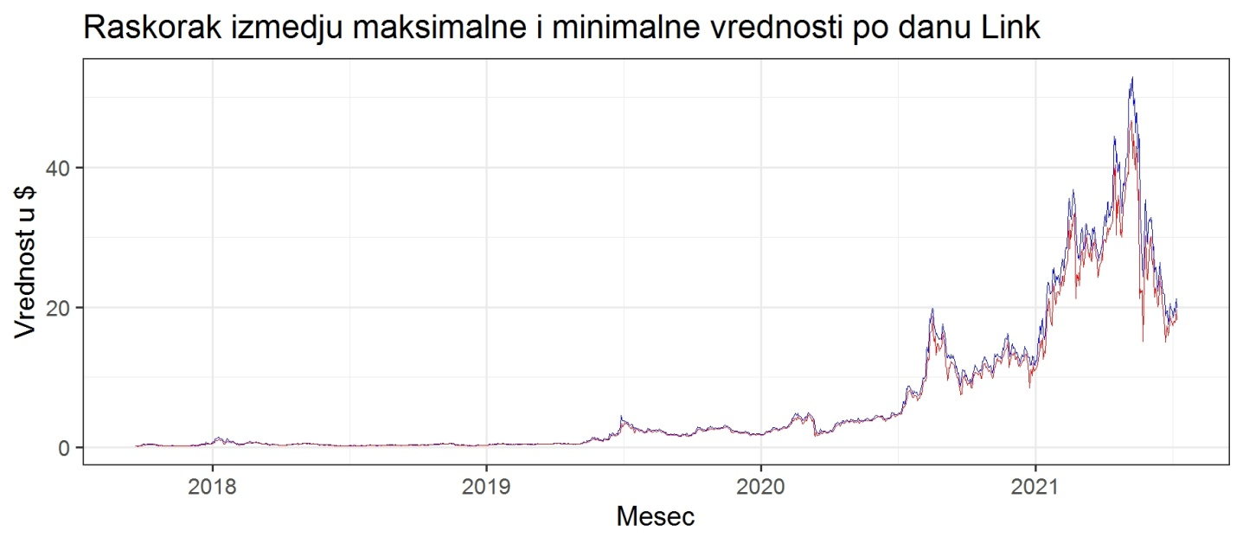**Image 27** - Difference between the minimum and maximum price per day for LINK

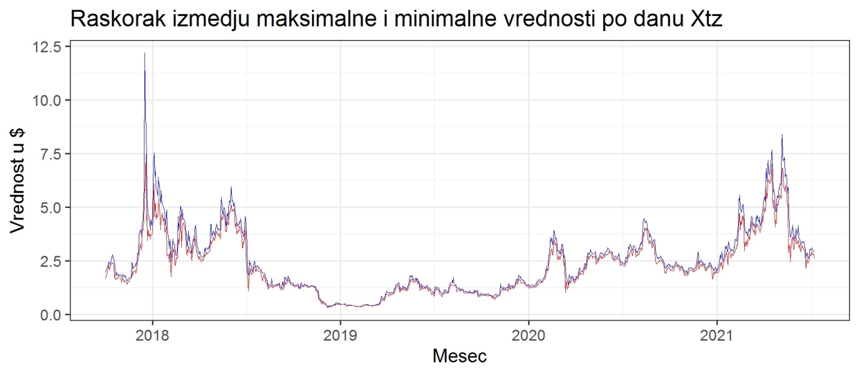**Image 28** - Difference between the minimum and maximum price per day for XTZ

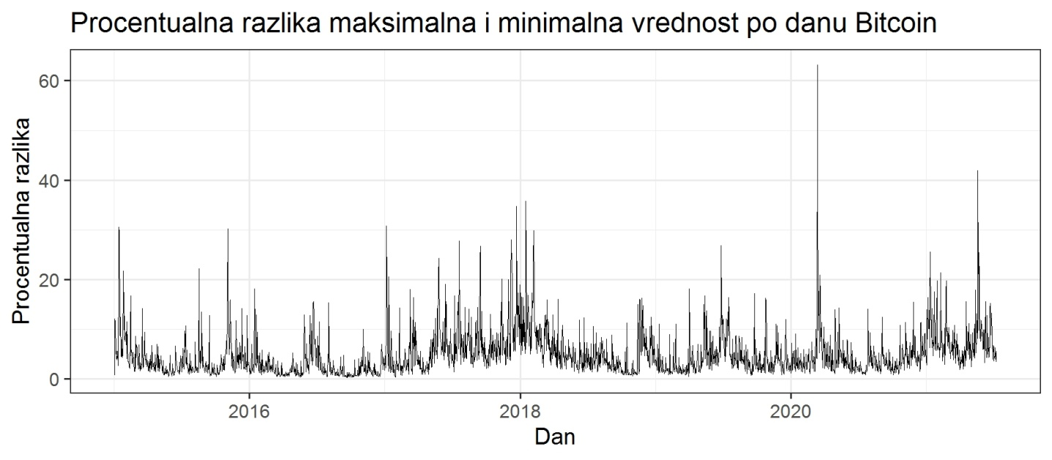**Image 29** - Percentage difference between minimum and maximum price per day for BITCOIN

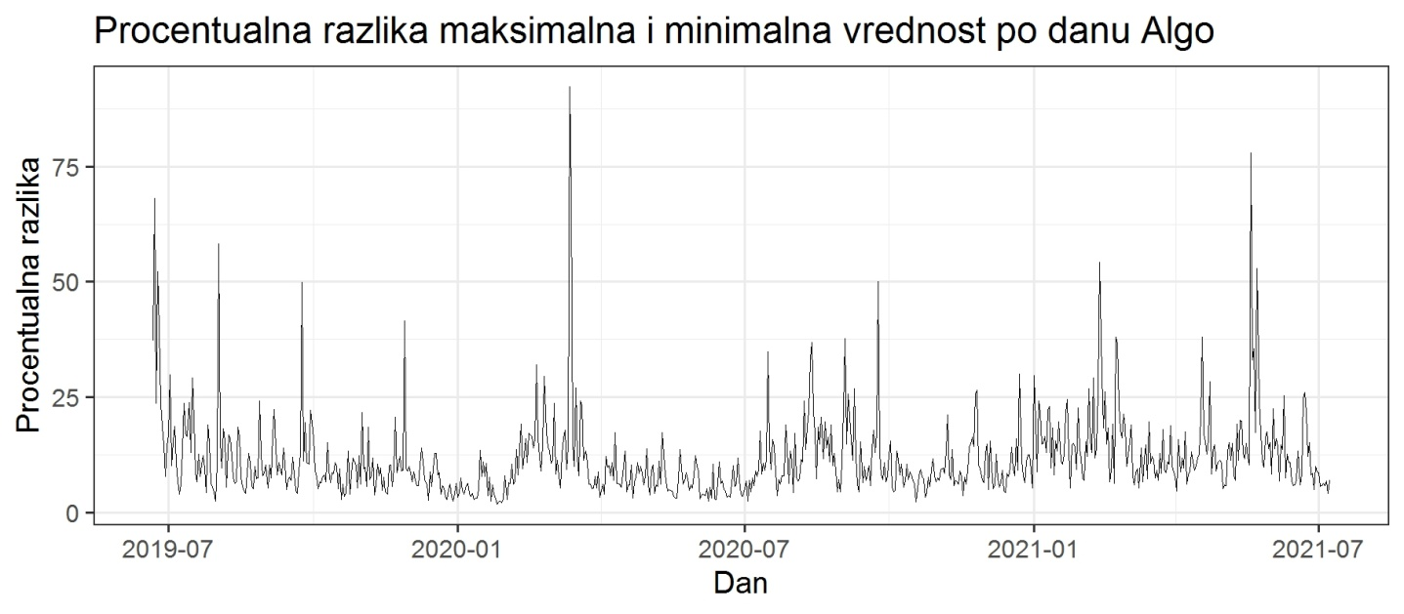**Image 30** - Percentage difference between minimum and maximum price per day for ALGO

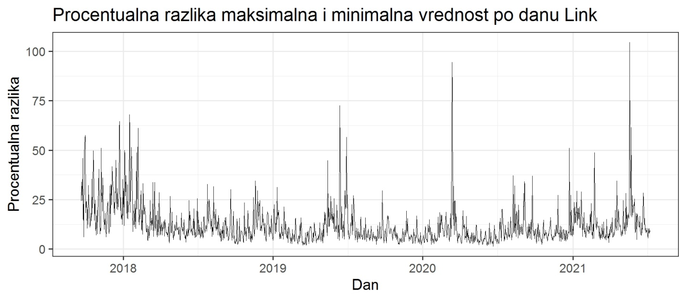**Image 31** - Percentage difference between minimum and maximum price per day for LINK

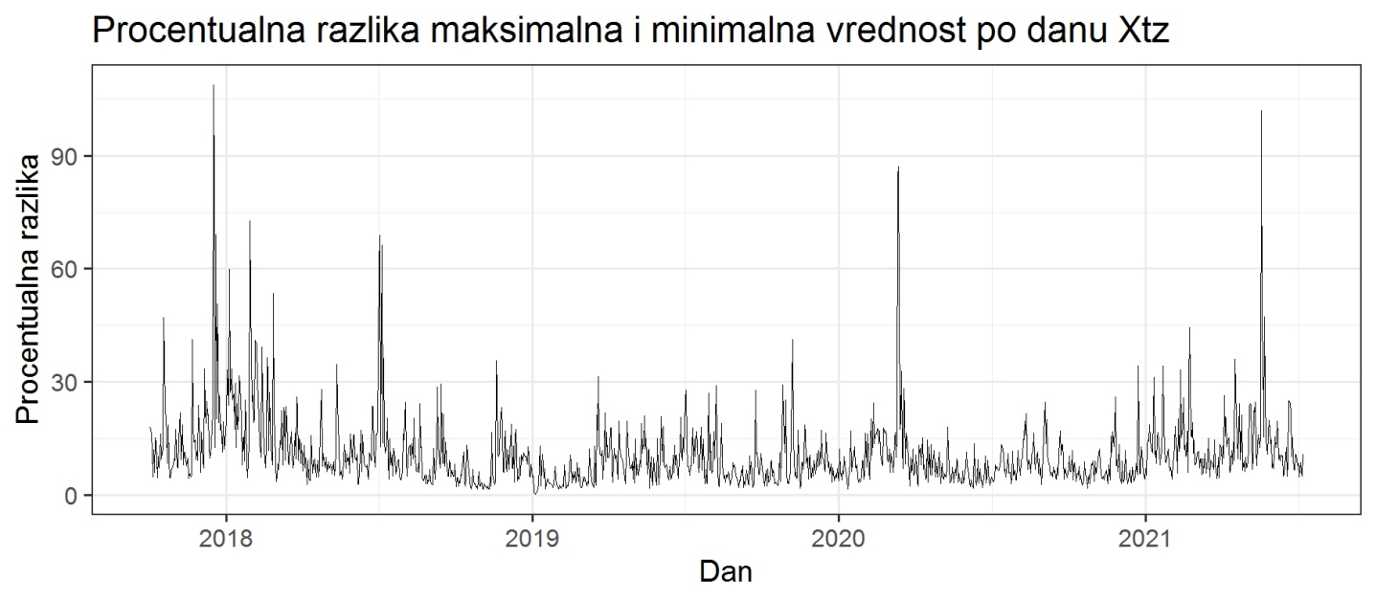**Image 32** - Percentage difference between minimum and maximum price per day for XTZ

In conclusion to this part we can say that the Bitcoin, judging by the historical data, presents a better option for those who invest in crypto in the long run, looking for an alternative to the abysmal interest rates on fiat savings and trying to minimize the effects of the ever looming danger of high inflation. Although some of the altcoins presented here, like ALGO and XTZ, carry staking rewards of between 5% and 6% APY and allow those skilled in technical analysis to earn on percentual difference between the lowest and highest prices per month, they are no match for Bitcoin when it comes to the long run. This is especially true for ALGO, which in my analysis didn’t stand out in anything (there are some pretty problematic mechanisms in its functioning, but that’s another topic). This means that they would be a good day-trading and short-term-holding tools, especially if you trade them with Bitcoin, earning compound profit in the long run.

Since this analysis is already getting too long, the following pages will contain only a short presentation of the sentiment analysis. The only thing to add here is that there is a lot of room for further analysis. It would be important to go through the changes in daily volume, to combine this numeric data with a complete fundamental analysis, as well as to gather data about specific milestones for each coin and look for correlations between specific events and price action, in order to extract important information for future decisions, and to construct predictive models for each coin. Besides that, I would like to point to the importance of Social Network Analysis, which could build on the data gathered for this task. By researching Twitter activities of the nodes which tweeted about these coins, we could construct a network of interactions, determining the centrality of each node (and the profiles of each coin/foundation), thus enabling us to determine who are the “opinion makers”, as well as to follow the most frequent words used in tweets about these coins (or crypto in general), topics which surround them and to determine (to some extent) the emotions that drive financial decisions of ordinary people (although, judging by the data gathered for this task, this would require a hardware setup that exceeds the one I have by far).

Having said that, let us jump quickly to sentiment analysis. The first thing that should be noted is the difference in metadata and gathered tweets (based on hashtags) as well as the time frame in which they have been published. As we can see from the next table, Bitcoin is absolutely dominating in every sense. Since the R package which I used has a limitation of 9 days when it comes to tweet scraping based on a hashtag (08.07. - 30.06.), and the maximum amount of 18000 tweets, “days in total” and “tweets based on a hashtag” don’t exceed these limits. It is amazing to see that Bitcoin got 17961 hashtags in only 1 day! Nothing comes even close to that. It is also the coin with the most followers. This also shows when it comes to sentiment analysis, as we can see from the following pictures. One thing should be noted here - the following analysis shows the number of ***words*** and not ***tweets*** which have been separated by the emotion that they carry. “Surprise” has been labeled as “neutral”, because I’m not sure about the “nature” of the surprise. Also, the number of tweets that were used for sentiment analysis is smaller than the number of tweets about these coinse, because only those tweets that were written in english have been taken into account.

|  |  |  |  |  |  |  |
| --- | --- | --- | --- | --- | --- | --- |
| **Coin** | **Followers** | **Friends** | **Tweets in total** | **Created** | **Tweets based on a hashtag** | **Days in total** |
| Bitcoin | 2874056 | 70 | 23282 | 8.18.2011 | 17961 | 1 |
| Algorand | 114879 | 510 | 2321 | 11.7.2017 | 1026 | 9 |
| chainlink | 394456 | 122 | 1241 | 6.19.2013 | 2876 | 9 |
| tezos | 124225 | 0 | 2690 | 6.22.2016 | 4310 | 9 |

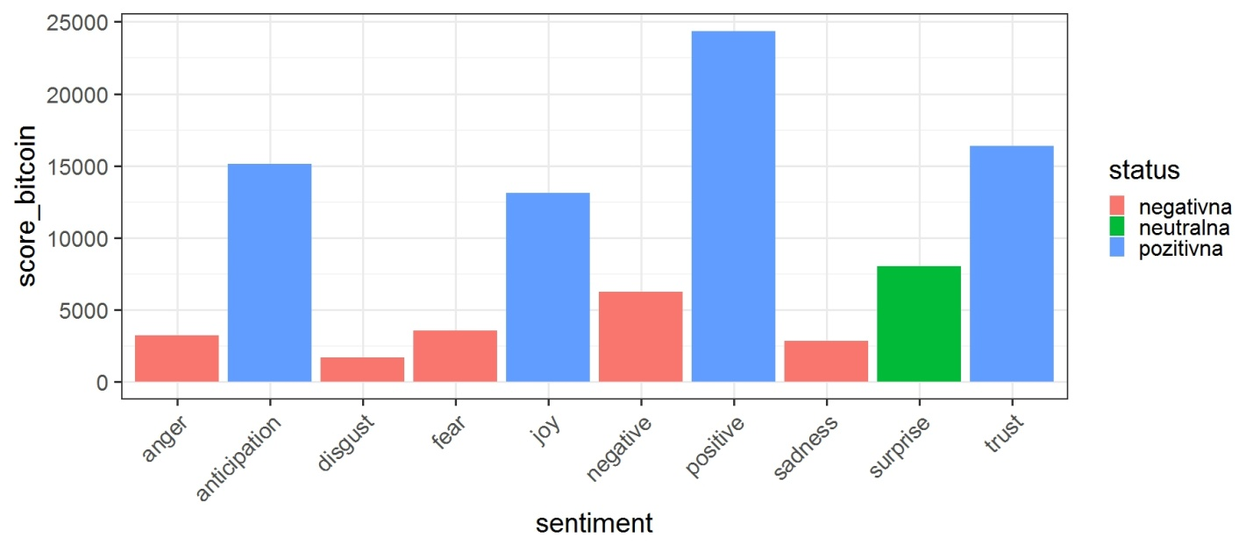

**Image 33** - Sentiment analysis for BITCOIN, showing the amount of words representing different emotions

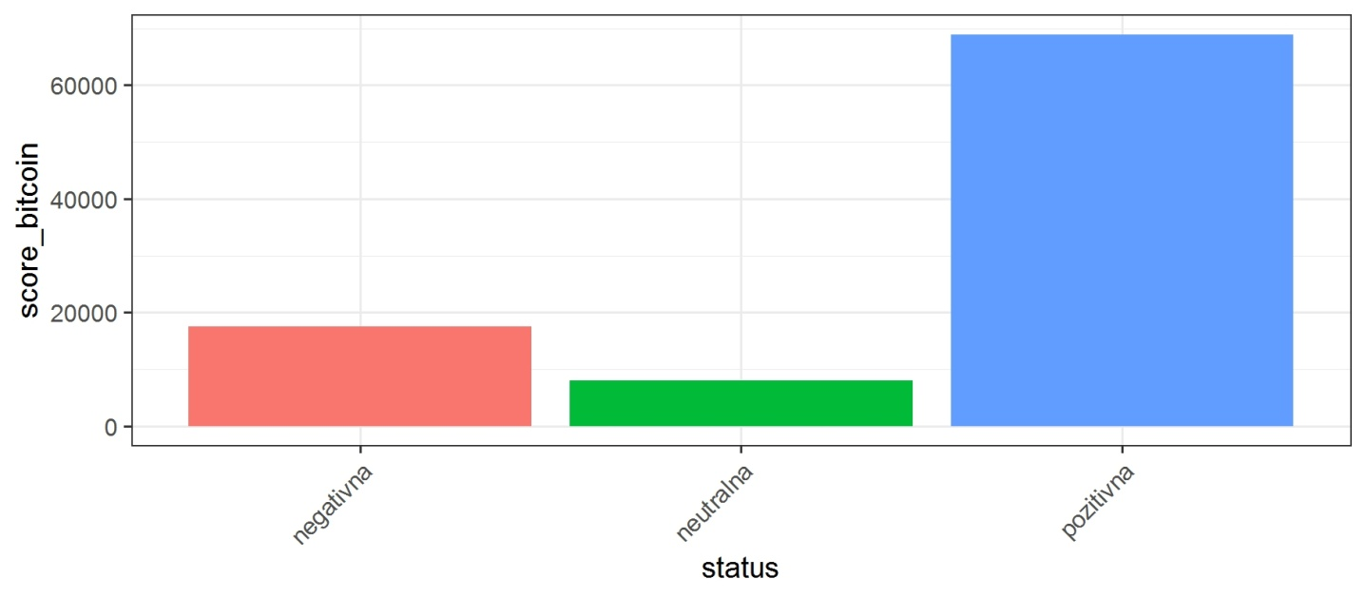

**Image 34** - Emotions summed by their level of positivity for BITCOIN

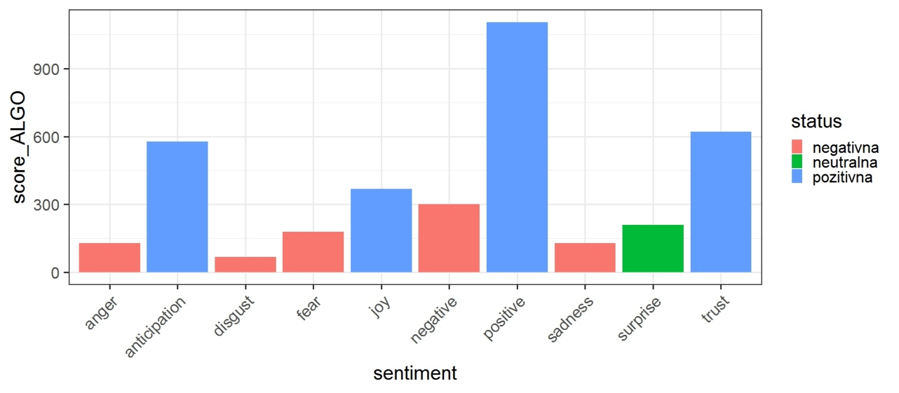

**Image 35** - Sentiment analysis for ALGO, showing the amount of words representing different emotions

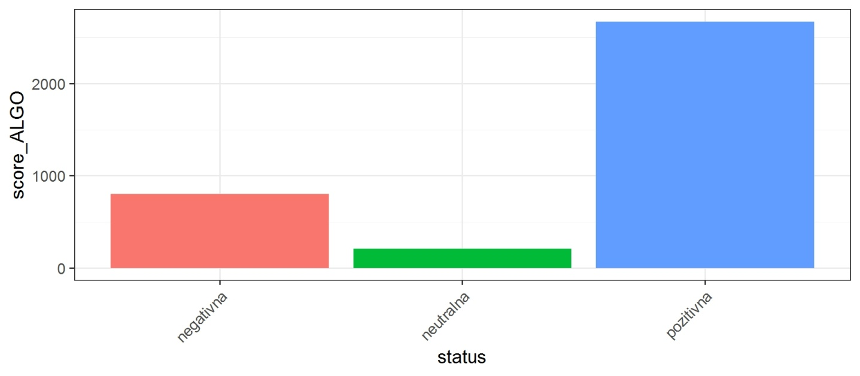

**Image 36** - Emotions summed by their level of positivity for ALGO

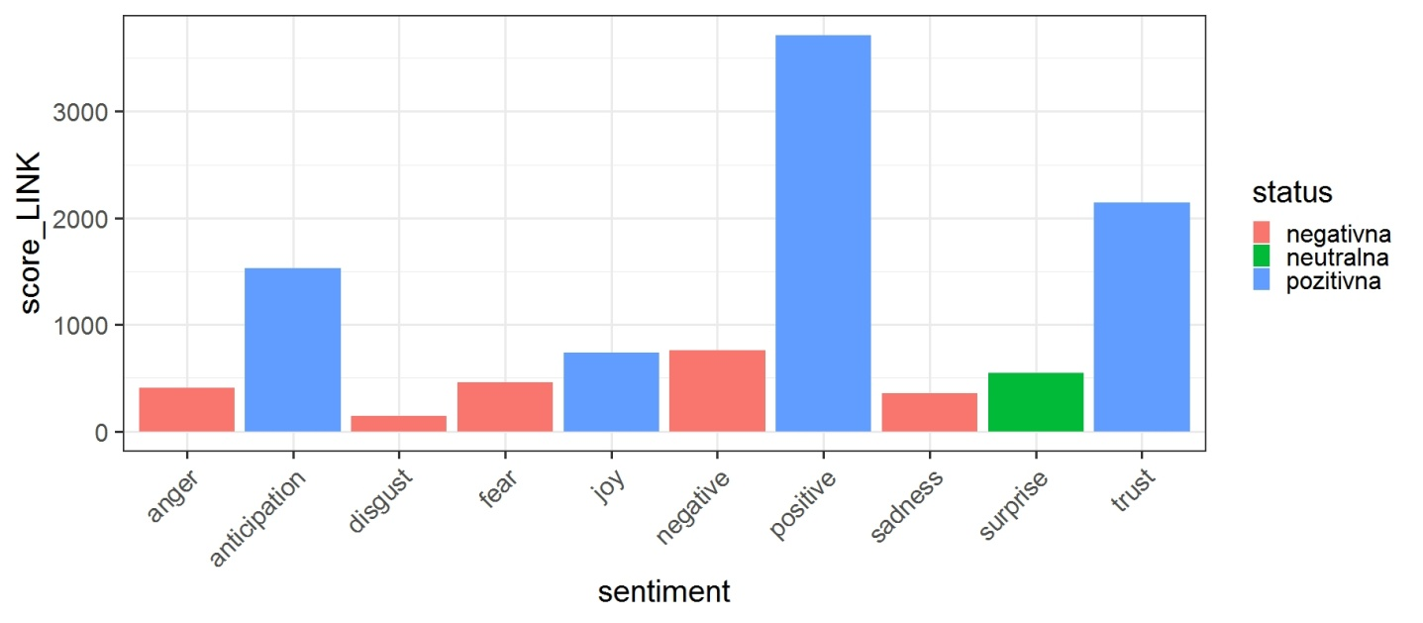

**Image 37** - Sentiment analysis for LINK, showing the amount of words representing different emotions

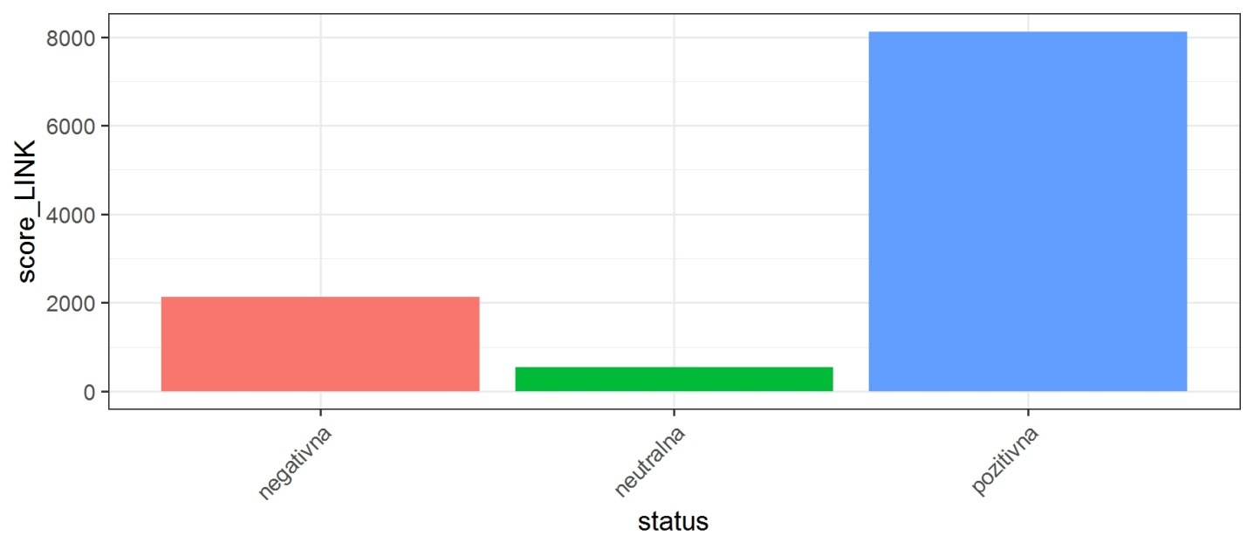

**Image 38** - Emotions summed by their level of positivity for LINK

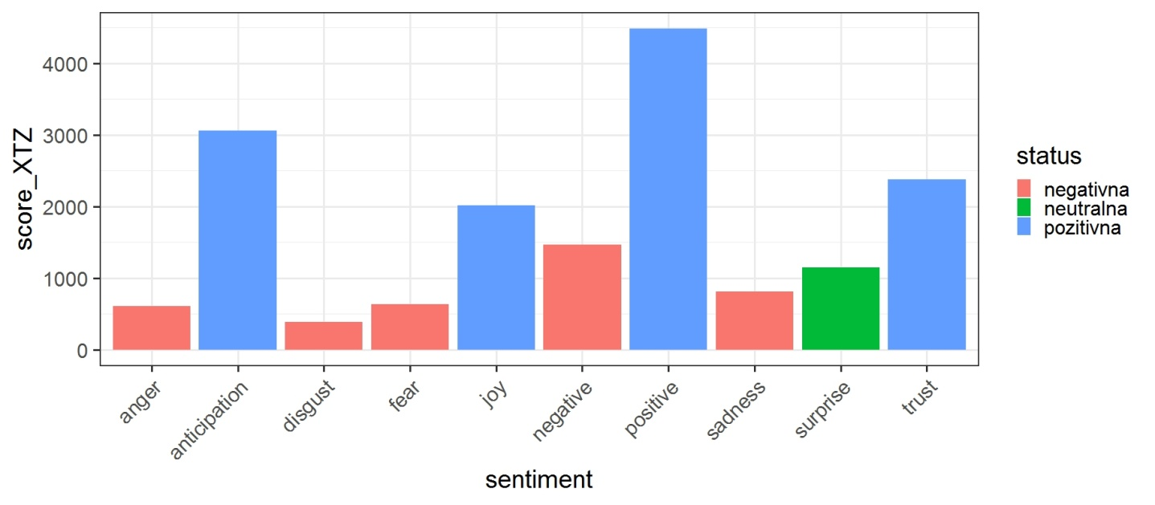

**Image 39** - Sentiment analysis for XTZ, showing the amount of words representing different emotions

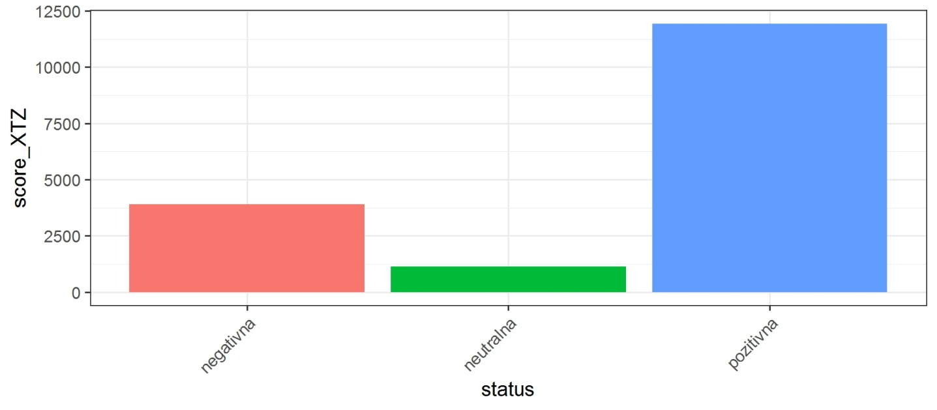

**Image 40** - Emotions summed by their level of positivity for XTZ

As we can see, all of the coins have predominantly positive emotions tied to them, although there is a big difference in the number of tweets and consequently the number of words tied to each one. Besides Bitcoin, XTZ was a relatively popular topic in the last 9 days, while ALGO had the worst result, both in terms of the number of tweets and the ratio of positive to negative emotions. This is, to a great extent, in line with the results I presented earlier. But, again, we have to be careful when deriving conclusions. It is obvious that the timeframe and the number of tweets are far from the limits required for rigorous scientific research. Besides that, the problem of fake profiles persists and further code development is needed in order to conclude how many of the followers are just “bots” uncritically promoting these coins/foundations and distorting the picture of their popularity.